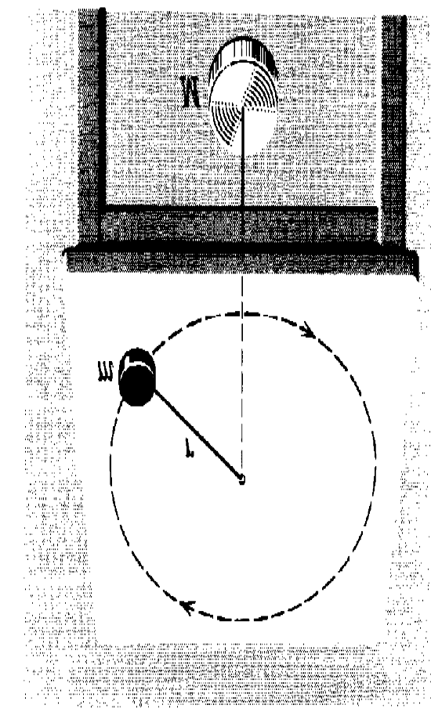
Problems

1. A mass m on a frictionless table is attached to a hanging mass M by a cord through a hole in the table. Find the condition (v and r) with which m must spin for M to stay at rest.

2. A small coin is placed on a flat, horizontal turntable. The turntable is observed to make three revolutions in 3.14 s.
(a) What is the speed of the coin when it rides without slipping at a distance 5.0 cm from the center of the turntable?
(b) What is the acceleration (magnitude and direction) of the coin in part (a)?
(c) What is the frictional force acting on the coin in part (a) if the coin has a mass of 0.002 kg?
(d) What is the coefficient of static friction between the coin and the turntable if the coin is observed to slide off the turntable when it is more than 10 cm from the center of the turntable?
Ans:0.3 m/s; 1.8 m s⁻², radially inward; 3.6 x 10⁻³ N; 0.37 

3. A block of mass m at the end of a string is whirled around in a vertical circle of radius R. Find the critical speed below which the string would become slack at the highest point?
4. A 1.0 kg ball is attached to a rigid vertical rod by means of two massless strings each 1.0 m long. The strings are attached to the rod at points 1.0 m apart. The system is rotating about the axis of the rod, both strings being taut and forming an equilateral triangle with the rod. The tension in the upper string is 25 N.

(a) Draw the free-body diagram for the ball.
(b) What is the tension in the lower string?
(c) What is the net force on the ball at the instant shown in the figure?
(d) What is the speed of the ball?
5. A boy is seated on the top of a hemispherical mound of ice. He is given a very small push and starts sliding down the ice. Show that he leaves the ice at a point whose height is 2R/3 if the ice is frictionless.

6. A sprinter runs at 9.2 m s⁻¹ around a circular track with a centripetal acceleration of 3.8 m/s².
(a) What is the track radius?
(b) How long does it take to go completely around the track at this speed?
Ans: 22.3 m ; 15.2 s 
Problems

1. A mass m on a frictionless table is attached to a hanging mass M by a cord through a hole in the table. Find the condition (v and r) with which m must spin for M to stay at rest.

2. A small coin is placed on a flat, horizontal turntable. The turntable is observed to make three revolutions in 3.14 s.
(a) What is the speed of the coin when it rides without slipping at a distance 5.0 cm from the center of the turntable?
(b) What is the acceleration (magnitude and direction) of the coin in part (a)?
(c) What is the frictional force acting on the coin in part (a) if the coin has a mass of 0.002 kg?
(d) What is the coefficient of static friction between the coin and the turntable if the coin is observed to slide off the turntable when it is more than 10 cm from the center of the turntable?
Ans:0.3 m/s; 1.8 m s⁻², radially inward; 3.6 x 10⁻³ N; 0.37 

3. A block of mass m at the end of a string is whirled around in a vertical circle of radius R. Find the critical speed below which the string would become slack at the highest point?
4. A 1.0 kg ball is attached to a rigid vertical rod by means of two massless strings each 1.0 m long. The strings are attached to the rod at points 1.0 m apart. The system is rotating about the axis of the rod, both strings being taut and forming an equilateral triangle with the rod. The tension in the upper string is 25 N.

(a) Draw the free-body diagram for the ball.
(b) What is the tension in the lower string?
(c) What is the net force on the ball at the instant shown in the figure?
(d) What is the speed of the ball?
5. A boy is seated on the top of a hemispherical mound of ice. He is given a very small push and starts sliding down the ice. Show that he leaves the ice at a point whose height is 2R/3 if the ice is frictionless.

6. A sprinter runs at 9.2 m s⁻¹ around a circular track with a centripetal acceleration of 3.8 m/s².
(a) What is the track radius?
(b) How long does it take to go completely around the track at this speed?
Ans: 22.3 m ; 15.2 s 

7. An airplane is flying in a horizontal circle at a speed of 480 km/hr. If the wings of the plane are tilted 45° to the vertical, what is the radius of the circle the plane is flying?

Ans: 1.8 km 

